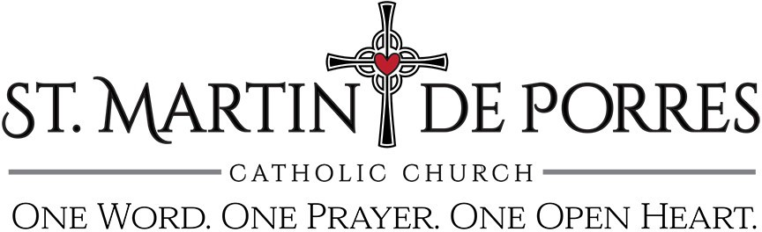

Mass Intention Request Form
The practice of requesting a Mass to be offered for loved ones, living or deceased, is a beautiful and wonderful part of our Catholic tradition. An individual may ask the priest to offer a Mass for several reasons, such as the intentions of another person, or as is most common, for the repose of the soul of someone who has died. Please read the following guidelines carefully:
- Requests will be honored on a first-come, first-served basis in order in which this form is received at the parish office
- Each family may request up to six (6) Mass intentions per calendar year
- A $5 stipend per Mass Intention is optional (checks must have “Mass Intentions” in the memo)
- If we are unable to fulfill a request on a particular date, it will be scheduled on the next available date

PLEASE RETURN COMPLETED FORM TO PARISH OFFICE, OR MAIL TO:
St. Martin de Porres Catholic Church 3990 W. University Drive Prosper, TX 75078

Name of Person for Whom Mass is Requested: Circle: Mass Date Requested:

Living / Deceased

Living / Deceased

Living / Deceased

Your Name: Your Phone Number: _

